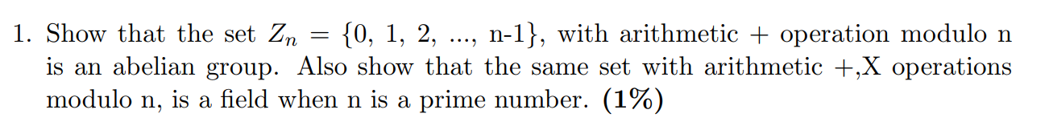  
An abelian group is one in which the axioms A1-A5 have to be met:

Let n = 6  
  
(A1) – Closure - Yes  
a+b mod z = x [X element of Zn]

Example: 1+2 mod 6 = 3, 5+4 mod 6 = 3   
  
(A2) – Associative - Yes  
a+(b+c) mod Z = (a+b) + c mod Z  
Example: (1+2) + 3 mod 6 = 1 + (2 + 3) mod 6 = 0

(A3) – Identity - Yes  
a+Ielement mod Z = a mod Z  
Identity Element = 0  
Example: 1+0 mod 6 = 1 mod 6, 0+1 mod 6 = 1

(A4) – Inverse element - Yes

a+(x) mod Z = Ielement  
For each element a its inverse is n-a

1 + (6-1) mod 6 = 0 [identity element]   
2 + (6-2) mod 6 = 0 [identity element]  
  
(A5) – Commutative - Yes  
a+b mod Z = b + a mod Z

2 + 4 mod 6 = 4 + 2 mod 6  
3 + 2 mod 6 = 2 + 3 mod 6

Therefore, it is an abelian group since A1 – A5 satisfied, we cannot find any counter-examples for each of the axioms.  
---------------------------------------------------------------------------------

Let n = 7

(A1) – Closure - Yes  
a+b mod z = x [X element of Zn]

Example: 1+2 mod 7 = 3, 5+4 mod 7 = 2   
  
(A2) – Associative - Yes  
a+(b+c) mod Z = (a+b) + c mod Z  
  
Example: (1+2) + 3 mod 7 = 1 + (2 + 3) mod 7 = 6

(A3) – Identity - Yes  
a + Ielement mod Z = a mod Z  
Identity Element = 0  
Example: 1+0 mod 7 = 1 mod 7, 0+1 mod 7 = 1

(A4) – Inverse element - Yes  
a + (x) mod Z = Ielement  
For each element it is n-a  
  
1 + (7-1) mod 7 = 0 [identity element]   
2 + (7-2) mod 7 = 0 [identity element]  
  
(A5) – Commutative - Yes  
a+b mod Z = b + a mod Z  
  
2 + 4 mod 7 = 4 + 2 mod 7  
3 + 2 mod 7 = 2 + 3 mod 7

Therefore, it is an abelian group since A1 – A5 satisfied.

(M1) – Closure under multiplication - Yes  
axb mod z = x [X element of Zn]

2x4 mod 7 = 1  
3x2 mod 7 = 6

(M2) – Associativity under multiplication - Yes  
ax(bxc) mod Z = (axb)xc mod Z

1 x (2 x 3) mod 7 = (1 x 2) x 3 mod 7   
  
(M3) – Distributive Law - Yes  
a(b+c) mod Z = ab + bc Mod Z

2 (2 + 3) mod 7 = 2(2) + 2(3) mod 7

(M4) – Commutative law under multiplication - Yes  
a x b mod Z = b x a mod Z  
2x3 mod 7 = 3x2 mod 7 = 6  
3x1 mod 7 = 1x3 mod 7 = 3

(M5) – Inverse element - Yes  
a x Ielement mod Z = a mod Z, IE = 1

2x1 mod 7 = 2  
3x1 mod 7 = 3  
  
(M6) – Non-zero divisor - Yes  
if axb = 0, then a = b or b = 0

(M7) – Multiplicative inverse - Yes  
  
a x (x) mod Z = IdentityElement

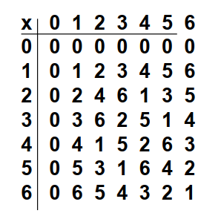This applies because if n is prime, then every value is relatively prime to n [within the set Zn {1,2…n-1}] and therefore have a gcd of 1.   
  
There exists a value such that its multiplication will result in the Multiplicative inverse element 1.

A1-A5 and M1-M7 hold, We also cannot find any counter-examples for any of the axioms. We can find a^-1 using the extended Euclid algorithm.  
  
  
  
(A1) Closure - Yes  
axb = c where c is an element of the set of non-zero real numbers

Yes  
2x1 = 2  
3x2 = 6

(A2) Associative - Yes  
ax(bxc) = (axb) x c

Yes  
1x(3x2) = (1x3)x2  
  
(A3) Identity - Yes  
axIe = a

Identity element = 1;

3x1 = 3  
  
(A4) Inverse element - Yes  
for all elements a in the set, there exists some b such that   
a x (b) = Identity element  
for any element a its inverse is 1/a

4\*(1/4) = 1

(A5) Commutativity - Yes  
a x b = b x a

4x1 = 1x4

Yes it is an abelian group A1-A5 apply; we cannot find any counter-examples for each of the axioms.  
  
  
  
  
((3^2 mod 5)^11 \* (3 mod 5)) mod 5  
((4 mod 5)^11 \* (3 mod 5)) mod 5  
((4 mod 5)^10 \* (4 mod 5 \* 3 mod 5)) mod 5  
((4^2 mod 5)^5 \* (12 mod 5)) mod 5  
((16 mod 5)^5 \* (12 mod 5)) mod 5  
((1 mod 5)^5 \* (12 mod 5)) mod 5  
= 12 mod 5  
= 2



{1234, 1243, 1324, 1342, 1423, 1432, 2134, 2143, 2314, 2341, 2413, 2431, 3124, 3142, 3214, 3241, 3412, 3421, 4123, 4132, 4213, 4231, 4312, 4321}

(A1) Closure - Yes  
for all elements in the set, when operated upon produces a value that is contained within the same set.

1234\*1243 = 1243  
  
(A2) Associative Law - Yes   
a\* (b \* c) = (a \* b) \* c

1423\*(1432\*1342) = (1423)\*(1243) = 1324   
(1423\*1432)\*1342 = (1243)\*(1342) = 1324

(A3) Identity Element - Yes  
a \* E = a  
E = 1234

1234\*3124 = 3124

(A4) Inverse Element - Yes  
a\*X = E  
X = a^-1

2314\*3124 = 1234

(A5) Commutativity - No  
a \* b = b \* a

1423\*3124 = 3412 [not the same]  
3124\*1423 = 2143 [not the same]  
We have found a counter-example.

A1-A4 apply, which suggests that this is a group, however the commutative law does not apply, the order of the operations alters the outcome of the results, and we have found one counter-example and therefore this set is not abelian.